Training on Kubernetes

Report created by Mithun G (60170590)

# Introduction

Kubernetes also known as K8s was built by Google based on their experience running containers in production. It is now an open-source project and is one of the best and most popular container orchestration technologies out there. To understand Kubernetes, we must first understand two things – Container and Orchestration. Kubernetes is a mainly a platform for hosting production grade applications.

# Containers

* Docker is a popular container technology out there.
* The need for containers:
  + Compatibility/ Dependency issues
  + Long setup time
  + Different dev/test/prod environment
* So, developing, building, and shipping the application becomes difficult because of the above issues.
* Using dockers we can run each component in a separate container with its own libraries and dependencies.
* All the same VM and OS, but with separate environments/ containers.
* So, dockers are used to containerize applications to run each service with its own dependencies in separate containers.
* Containers – basically layers of images are completely isolated environments, as in they can have their own process and services, their networking interfaces, just like VMs, except they share the same OS kernel.
* In simple terms, Docker containers share the underlying OS Kernel.
* Say, for example Docker is installed on Ubuntu OS, docker can run a container based on another distribution like Fedora, Debian or even Cent OS as they all use the same kernel – Linux kernel.
* The main purpose of dockers is to containerize applications and to ship them and run them.

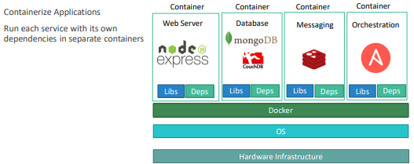

Fig 1. 1 Docker underlying architecture